Name:_______________________ Due Day 5 Unit 5 Week 3
Day 1: Spelling - Write spelling words 3X's each on a separate sheet of paper.
Day 2: Sequence in Biographies
Walter Elias Disney was born on December 5, 1901. Walt began to draw at age 5 and took art classes on the weekends. He even traded his drawings to the local barber for free haircuts. In high school, Walt took classes at the Chicago Art Institute and drew for the school newspaper. When he was 16, Walt wanted to help fight in World War I. Since he was still too young to join the army, he joined the Red Cross instead. He spent the next year driving ambulances for the Red Cross in France.
Walt returned from the war ready to begin his career as an artist. He started his own company to make short movie cartoons. Although the cartoons were popular, the business didn't make enough money. One failure was not going stop Disney! He opened another new business with his brother. It was doing well at first, but once again, Walt had to start over. This third time he created a new character named Mickey Mouse, and he made the first short movie with sound by doing the voices himself. The movie was a great success! Disney continued to work, creating new characters such as Donald Duck, Goofy, and Pluto.

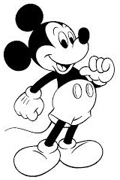
In 1932, Disney decided he wanted to make a long movie called Snow White. People thought he was crazy for trying to make a cartoon that long. It took five years to complete the movie! It was a huge success and became the top film of 1938. Disney used the money from Snow White to make more movies like Pinocchio, Dumbo, Bambi, Alice in Wonderland, and Peter Pan.

Walt Disney had the great idea to create a theme park with rides based on his movies. Disneyland opened in 1955. It cost $17 million to build! The park is still one of the most popular places to go on vacation in the world. Even though Walt Disney had many failures at first, he never gave up. Working hard pays off!

Write first, next, then or last on the line next to each sentence to show when it happened in the story about Walt Disney. They are not in order.

_______________ Disney took 5 years to make a long movie called Snow White.

_______________ Walt Disney created the idea for the theme park Disneyland.

_______________ He traded his drawings to the local barber for free haircuts.

_______________ Walt made a character named Mickey Mouse.

Day 3: Synonyms

Read each sentence and then circle the word that BEST replaces the underlined word because they have almost the SAME meaning.
- Walt returned from the war ready to begin his career as an artist.
  - acting b. job c. home d. color

- Although the cartoons were popular, the business didn't make enough money.
  - liked b. popped c. unfair d. equal

- It took five years to complete the movie!
  - compare b. camp c. finish d. start

- The park is still one of the most popular places to go on vacation in the world.
  - vet b. suitcase c. Disneyland d. trip
Sequencing (practice continued from Day 2- use the Walt Disney story again)
- When did Walt Disney begin to draw?
  - Age 8
  - When he was 7
  - In high school
  - Age 5
- AFTER Walt Disney was successful at making long movies, he
  - Joined the Red Cross
  - He started doing voices of the characters
  - Got the idea for Disneyland
  - Created a character named Mickey Mouse
- BEFORE Walt Disney drove ambulances, he
  - Drew for the school newspaper
  - Opened a business with his brother
  - Made a movie called Snow White
  - Married a woman named Casey

We read Brave Bessie on page 443 in the Literature Anthology. Please reread this story with your child and answer the Respond to Reading questions on page 453.

Day 4- Vocabulary Words
Word Bank
agree challenging discover heroes
interest perform study succeed

Word: _______________________  Definition: to have the same feeling or opinion | Picture:
Word: _______________________  Definition: to like something and want to know more about it | 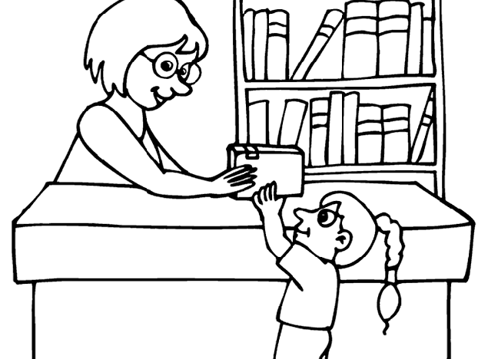  Picture:
Word: _______________________  Definition: to give a show in public | Picture:
Word: _______________________  Definition: the ability to do well at what you want to do | Picture:
Word: _______________________  Definition: to try to learn | 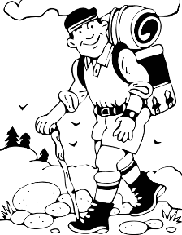  Picture:
Word: _______________________  Definition: difficult to do something | Picture:
Word: _______________________  Definition: brave people | Picture:
Word: _______________________  Definition: find something | 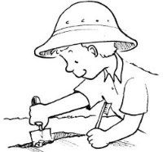  Picture:

Day 5: Unit 5 Week 3 Reading, Grammar, & Vocabulary tests, will be given in class.

