Unit 4 Week 4
Name:___________________________ Due Day 5
Day 1- Spelling:
Write your spelling words 3X's each on a separate sheet of paper.

Day 2 - Grammar:
Irregular Verbs give, sing, sit
Change the verbs in the bold print to the past tense. Write the new sentences on the lines below.

1. Native Americans give us stories about nature.

__________________________________________________________________

2. They sit around fires and told stories.

__________________________________________________________________

3. Sometimes, they sing the stories.

__________________________________________________________________

4. Some stories give reasons for things in nature.

__________________________________________________________________

5. Children sit quietly during the stories.

__________________________________________________________________

Day 3- Root Words are the basic parts of a word. A prefix or suffix can be added to a root word. For more information, see page 311 in the small book. Match the words below that have the same root word.
- __f__small a. closed
- _____opening b. angrily
- _____lovely c. quickly
- _____closely d. loving
- _____quicker e. opened
- _____anger f. smaller

- The word nibbled has a root word nibble, meaning, “chew.” What does the word nibbled mean?
  - colored
  - ate
  - looked
  - sang
- Based on the root word starve, what does starving mean?
  - serving
  - closing
  - hungry
  - happy
- Based on the root word shove, what does shoves room?
  - pushes
  - pulling
  - shovel
  - sharing
- The word shouted has a root word shout, meaning, "scream" or “yell.” What does the word shouted mean?
  - should
  - yellow
  - whispered
  - screamed

We read How the Beetle Got Her Colors in class today. Please reread this with your child and answer the Respond to Reading questions on page 379. The students will take an AR test on this story in class tomorrow.

Word Bank
ashamed holler victory dash
boast similarities wisdom plenty

Day 4 - Vocabulary Words
Word: _______________________  Definition: more than enough | Picture:
Word: _______________________  Definition: move fast | 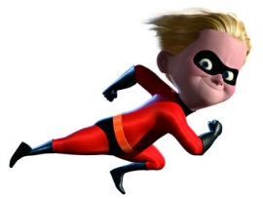  Picture:
Word: _______________________  Definition: winning a contest or game | Picture:
Word: _______________________  Definition: feeling bad about something you have done | Picture:
Word: _______________________  Definition: to shout | Picture: .
Word: _______________________  Definition: brag about something | Picture:
Word: _______________________  Definition: things that are alike | Picture:
Word: _______________________  Definition: knowing information | 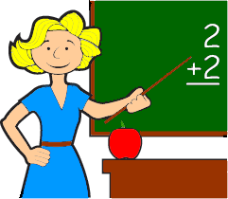  Picture:

Day 5 - Unit 4 Week 4 Reading & Vocabulary Test, Grammar Test, will be given in class.

