Unit 5 Week 5
Name:______________________
Day 1 - Spelling
Write your spelling words 3X's each on a separate sheet of paper.
Day 2 - Cause and Effect
If You Give a Dog a Bone
“Grrrrrrowl!!!” went the hungry dog’s stomach! He barked so his owner would come feed him. Chipper the dog was really craving a giant, juicy bone. He wondered if his human friend, Carl, would be feeling kind today. To Chipper’s delight, Carl walked in with a big bone and gave it to Chipper. A small, happy bark escaped Chipper’s mouth. After he finished gnawing on the bone, he started to want a big bowl of water to wash it down. Chipper stood by the sink and barked again until Carl walked in the kitchen and refilled the water bowl. Then, Chipper was feeling full and happy. He laid down on the couch next to Carl and curled up for a short nap.
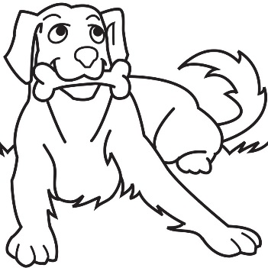
When Chipper woke up he was feeling lazy. He decided it was definitely time for some running around. He stood by the back door and put his paw on the door knob until Carl walked over and opened the door. Chipper sprinted around the backyard, sniffing every blade of grass. Doing this made him want to explore the grass outside of the backyard. So he walked over to Carl with his blue leash hanging from his mouth. Carl rolled his eyes because he was in the middle of reading a really interesting chapter book. He knew that having a dog was a big responsibility so he decided to be a good owner. Carl happily took Chipper for a walk around the neighborhood and thought about all of the activities that happened because he gave Chipper a bone.
- What did Chipper do when he wanted water?
  - Put his blue leash in his mouth
  - Put his paw on the door knob
  - Curled up next to Carl on the couch
  - Stood by the sink and barked
- Why did Carl decide to take Chipper on a walk even thought he was busy?
  - The book wasn’t that good anyway.
  - He knew that it was his responsibility to be a good owner.
  - Carl wanted to give Chipper a treat for being so good.
  - The neighborhood was perfect for walking dogs.
- Why did Chipper decide to take a nap?
  - He was feeling lazy.
  - He was feeling silly.
  - He was feeling full and happy.
  - He liked to curl up on the couch.

Day 3 - Grammar
• A present-tense verb must agree with the subject pronoun
of the sentence.
• Do not add s to most verbs in the present tense with the
pronouns I, we, you, and they.

Circle the verb in ( ) that agrees with the subject pronoun in each
sentence.
1. We (like, likes) to visit historic places.

2. I (plan, plans) to visit the Liberty Bell.

3. They (wants, want) to see it, too.

4. We (know, knows) all about the bell.

5. You (plans, plan) to share part of the story, don’t you?

6. I (reads, read) lots of books about history.

7. You (show, shows) us what our country was like long ago.

8. I (thinks, think) the bell is a special gift from the past.

We read Setting the Rules today in class. Please reread this selection with your child tonight and answer the Repond to Reading questions on page 483.

Word Bank
exclaimed finally form history
public rules united writers
Day 4- Vocabulary Words

Word: _______________________  Definition: when things or groups are joined together | Picture:
Word: _______________________  Definition: what has happened in the past | Picture:
Word: _______________________  Definition: for all people to use of visit | 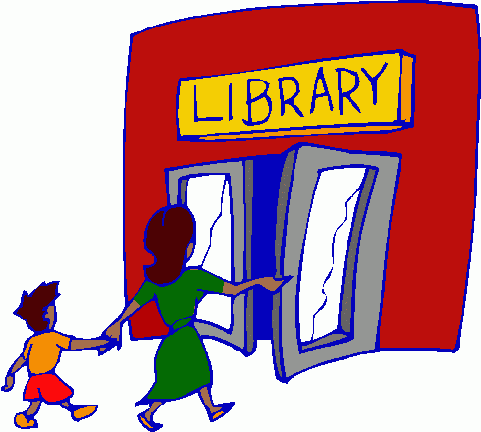  Picture:
Word: _______________________  Definition: shouting suddenly because you’re excited or upset | Picture:
Word: _______________________  Definition: when something happens at last | 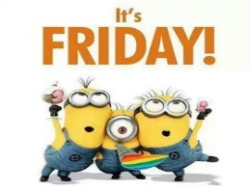  Picture:
Word: _______________________  Definition: people who write or type stories or articles | Picture:
Word: _______________________  Definition: what you must or must not do | 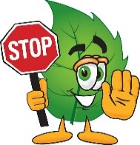  Picture:
Word: _______________________  Definition: make something or put it together | Picture:

Day 5 - The Unit 5 Week 5 Reading, Grammar, & Vocabulary Tests will be given in class.

